OnlineMECMonitoring – Documentation

# How to use the application

After following the devices’ respective installation guide below, this section will help instruct the user on how to use the program. The MEC monitoring program can be run on the Raspberry Pi (RPI) and Windows devices. However, many functionalities of the MEC program are limited on Windows devices.

On RPI devices, two concurrent power supplies can be used alongside a t3 pi-hat and tinker plate pi-hat. This enables the concurrent monitoring of voltage and current of two power supplies, the 2 temperatures and pH measurements and the pH control system. The program will automatically start on RPI start-up. If the program hangs, it is recommended to restart the RPI and let the program start again.

On Windows devices, only the two concurrent power supplies are supported. If the program hangs, it is recommended to open the task manager and end application process.

# Raspberry Pi Installation Guide

Run the *LinuxMECinstall.sh.command* located in *OnlineMECMonitoring/Version2* by double-clicking it. Make sure to execute file in terminal by selecting the “Execute in Terminal” option. (**Once the script is done running it will automatically reboot the Raspberry Pi, so make sure that all work is saved before running the script. The terminal can be closed to cancel the operation).**

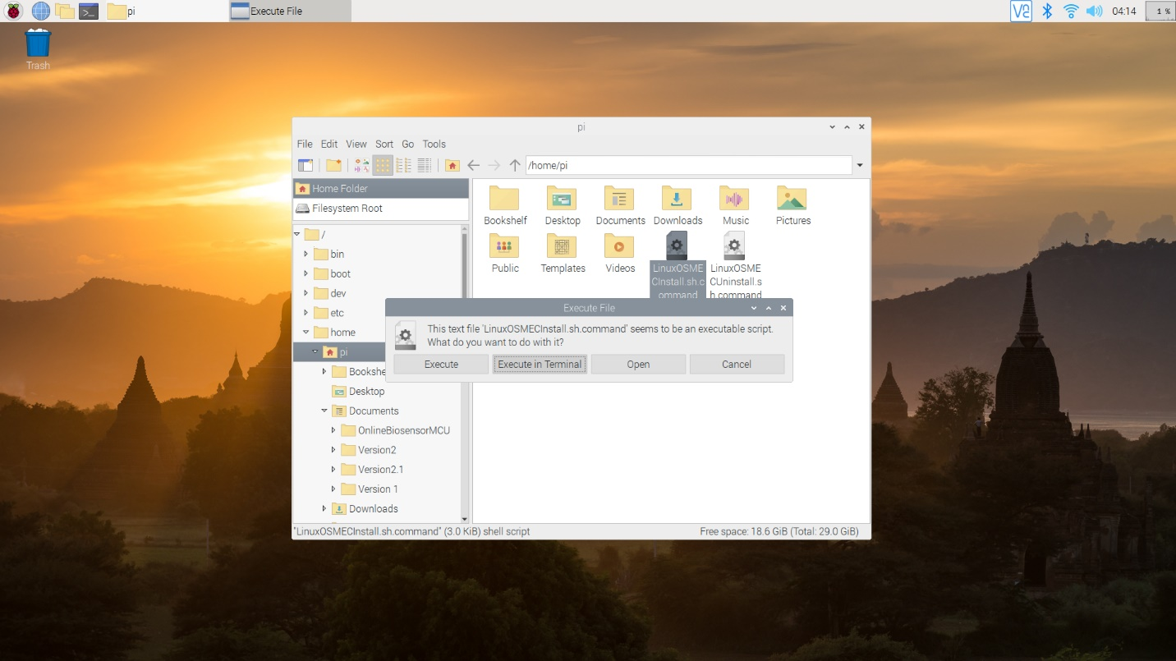

It will open the terminal window and begin installing all the appropriate packages and create the shortcuts. This process will take some time so please wait patiently.

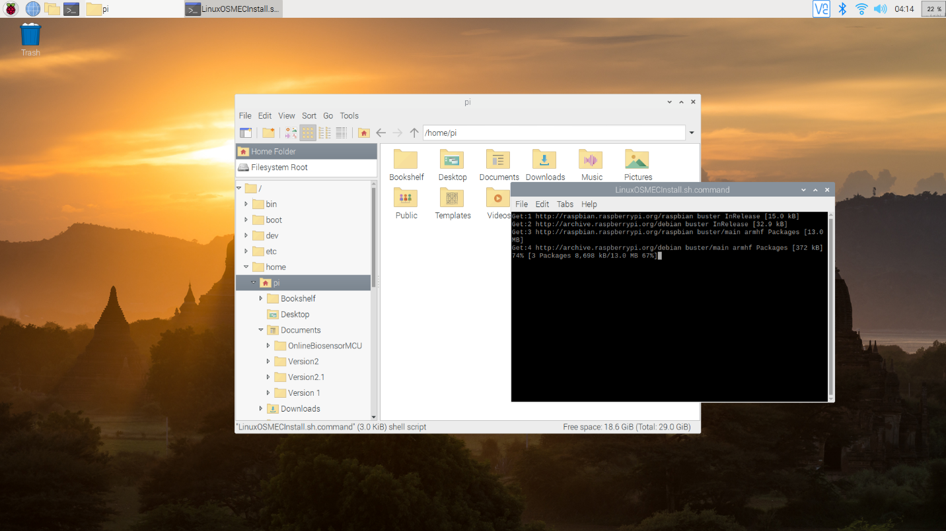

After the script is done running, the Raspberry Pi will automatically reboot. This is what the desktop should look like after reboot. There will be one folder for the application settings file and another folder which contains all the data files.



After a few seconds, the biosensor application will automatically start, and the installation can be confirmed as successful.

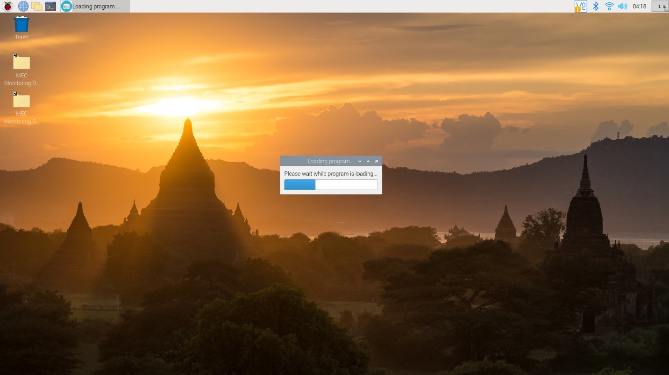

*Important features and quality of life fixes*

* **The application is available in the start menu in the ‘other’ category. If you want to start the application after an accidental close, look there.**
* If the installation fails to install, follow the checklist below:
  + Make sure the installation script is for the most up-to-date version for the application and try again. **(Note: Before using the new installation script, use current uninstallation script to remove all files beforehand. This will create a clean environment for your installation of the program. Make sure you save your settings and data files in the user preferred location before uninstallation as it will remove all MEC folders.)**
  + If this fails, let the developer know.

*For developers of the installation script*

* Usually, installation/uninstallation failures and either be attributed to the following files -> LinuxMECInstall.sh.command, LinuxMECUninstall or runMECMonitoring.sh. If the location of the files is different, then these files must be adjusted accordingly. For example, if the location of the installation is moved, from usr/share/ to /home/pi for example. Then, in every file, instances of /usr/share/ regarding the location of the data must be changed properly. (**Note: the start menu option is in /usr/share/applications/).**
* Otherwise, it is most likely due to changes in python packages which caused certain dependencies to be different, or perhaps a certain function has been deprecated. In this situation, try running the installation script on a fresh boot and then testing the code by running the BiosensorMain.py fie via Thonny IDE, and test where it fails.

# Windows Installation Guide

Run the *MEC_WindowsInstaller.exe* located in *OnlineMECMonitoring/Version2/Windows Installation*/ folder location. The user may choose to install in onto all users, as an administrator, or for the single user.

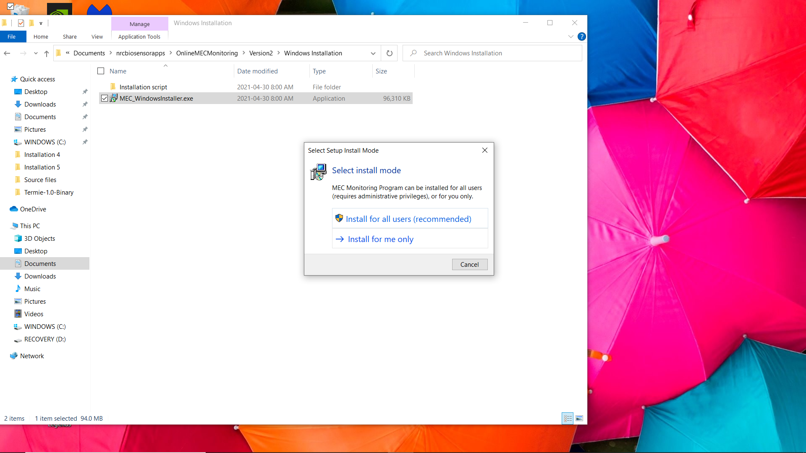

Then the installation language can be selected.

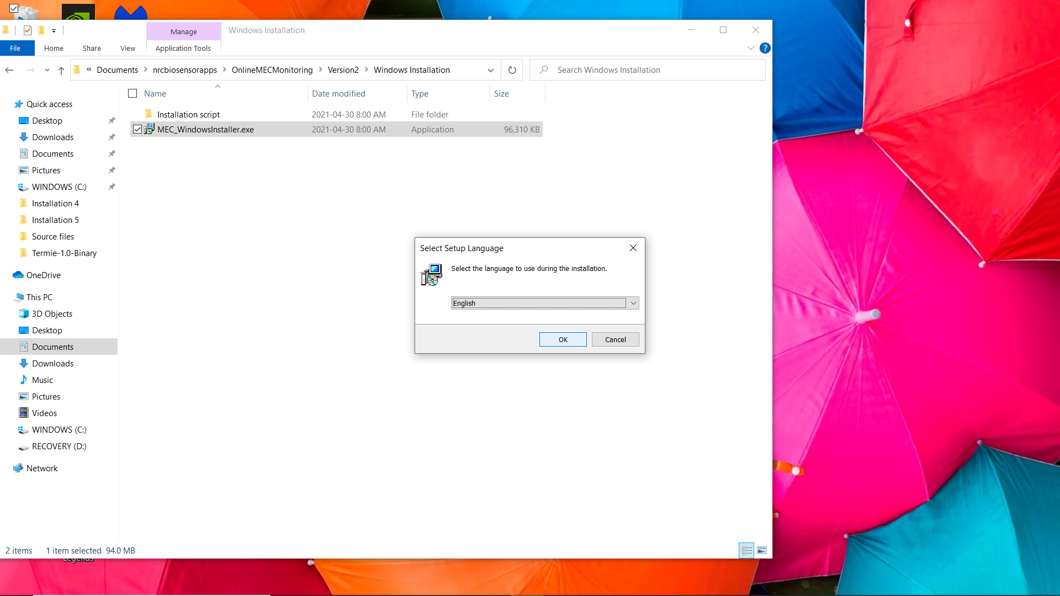

Then the user will be prompted to install the application. **It is advised to not place the application inside the *Program Files* folder or *Program Files (x86)* folder**. **If this is done, every time the application is run, it must be run as an administrator. To do so, right-click the application and select run as administrator.** Other locations will not require this step and are safer to use. (By default, the C drive is selected)

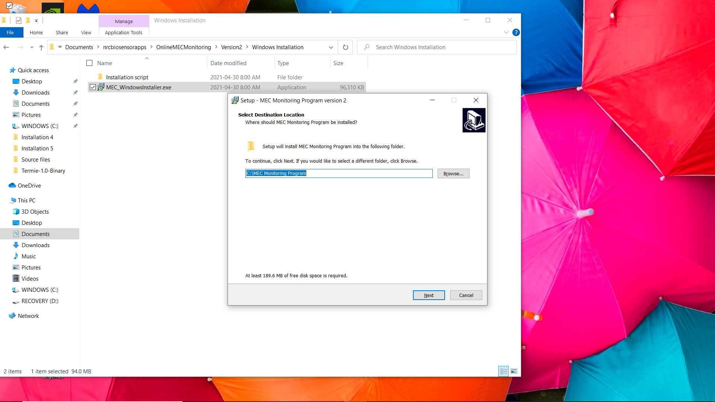

Then the user is prompted to add a shortcut to the program on to the desktop. This step is recommended since the data from acquisitions will be visible on the desktop as well. The application is also visible in the start menu.

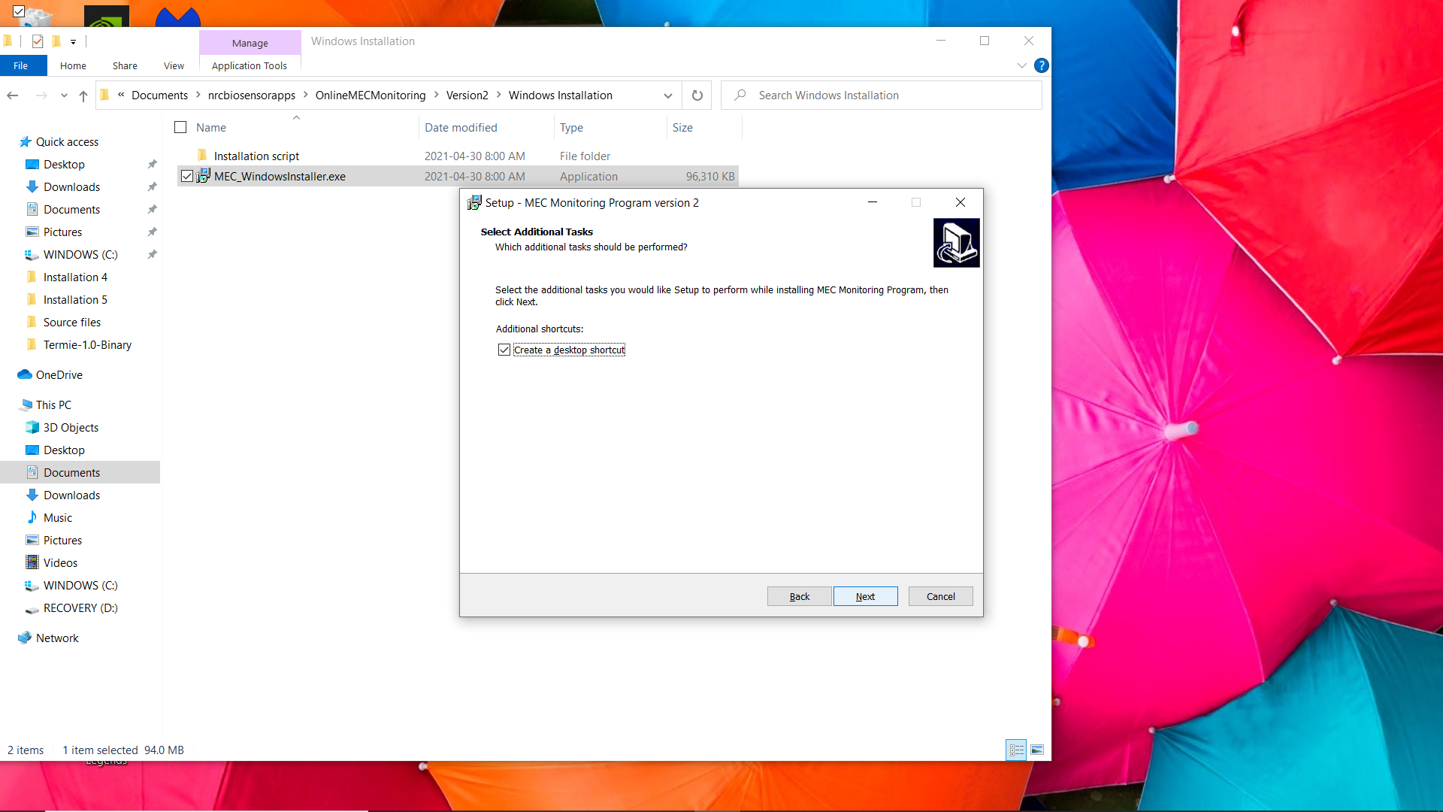

Now the application can be installed.

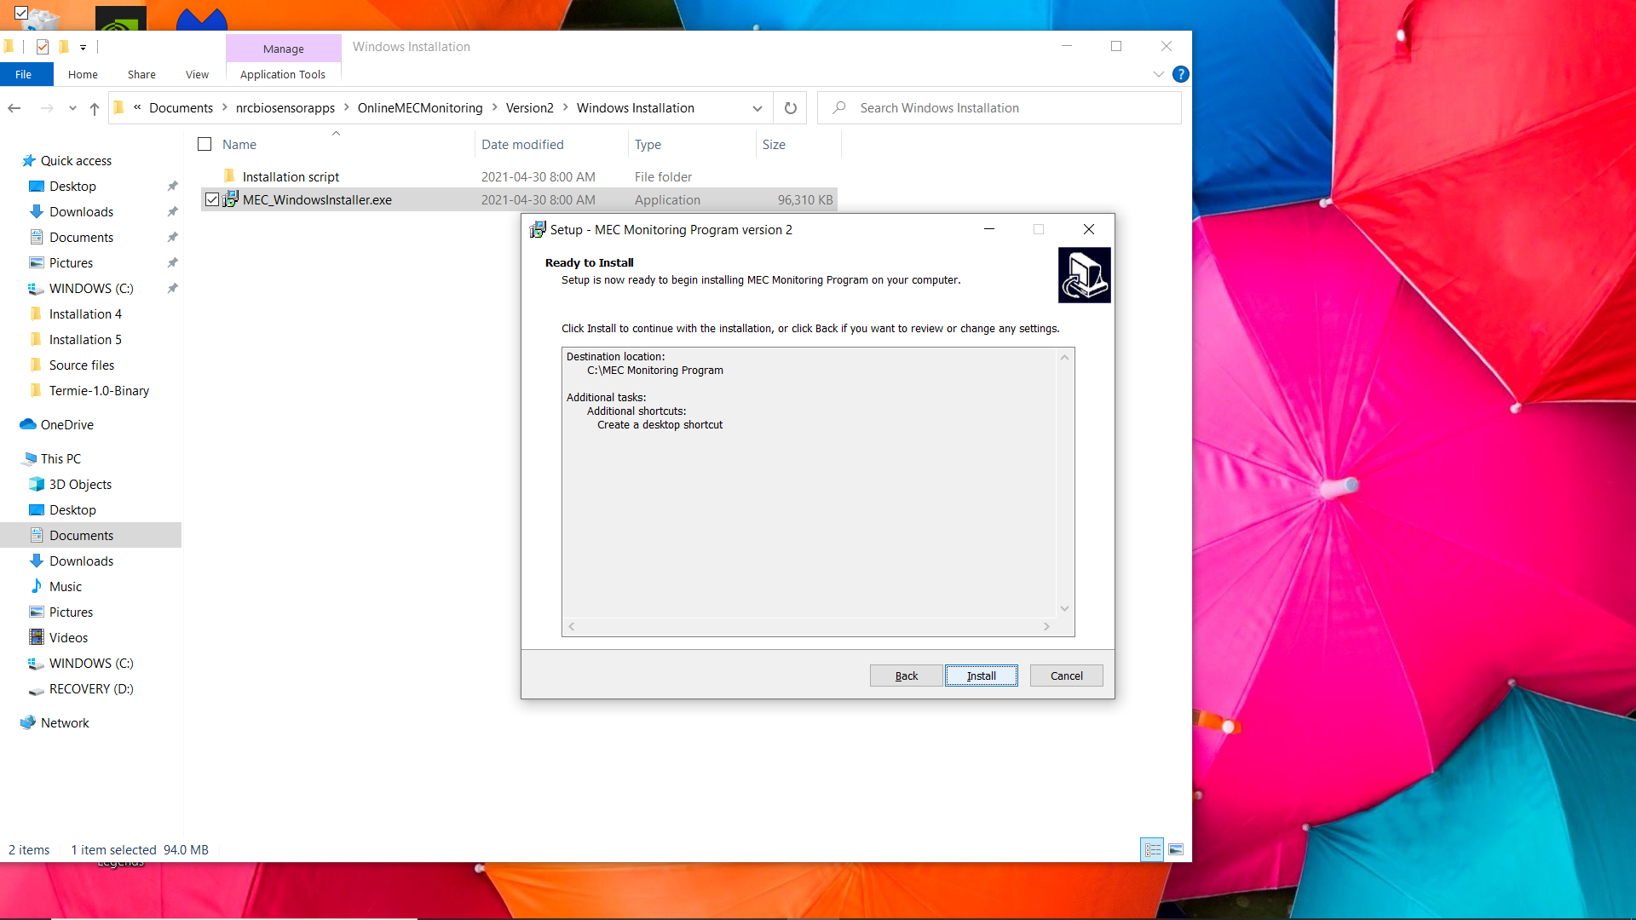

After the installation is finished, the shortcuts will be available in the desktop.



*Important features and quality of life fixes*

* To uninstall the program, go to the installation location and execute the uninstall00.exe. It will do most of the uninstallation. But it will not remove the data logs or settings if they were modified. So, if the removal of the entire program is desired, it is recommended to manually delete the data logs/settings files.
* If the UI elements are not loaded in properly, try to uninstall the program and re-install via the installer and see if it fixes the issue.
* If the user receives the error “*BiosensorApplication Script has failed to run”,* the application is most likely saved in an administrator folder. There are two methods to resolve the problem, run the application as an administrator or uninstall the program and install it into a non-administrative folder.
* The program may also suffer from a crash where it says “KORAD_PS_DAQ.exe has stopped unexpectedly”. In my experience, this occurs when your device has a problem with pyqt5. If you wish to investigate, open event viewer, and view the application failure. If it the crash is due to PyQt5Core.dll, then your pyqt5 module is most likely corrupted. The only tested solution with some success for this was a PC reset.

# Developer’s Guide Tips and Tricks

## Raspberry Pi

* By default, on the Raspberry Pi 3, python3.7 and python 2.7 are installed. When editing this program, make sure python 3.7 is used when testing and debugging.
* When using *LinuxOSinstall.sh.command* located in *OnlineBiosensorMCU/Version 1/Installation files/* to install the Biosensor Application, it automatically installs useful qt-dev tools, which are used to design the .ui files. For example, the “Qt 5 Designer” application can be found in the programming category of the start menu. It is recommended to use the application to design the UI and to load the UI files into the python program in the code.
* When designing scripts, make sure the scripts are set to executable.
* When editing the repository file/folder format, the installation/uninstallation scripts, located in *OnlineMECMonitoring/Version2/*, and the *runMECMonitoring.sh* scripts located in *OnlineMECMonitoring/Version2/* will need to be modified. When editing the script files replace every “Source files” keyword with the new location of the script file.

## Windows

* To develop this program on windows, python3.7 or python3.8 and pip installed. Both environments are functional and tested.
* The program was initially designed and programmed in python. However, the final product was an installation file. To do this, the workflow went from functional python file to an executable program and then to an installation executable. This section explains the steps necessary steps to go from a functional python file to an installation file. **Disclaimer**: **At the time of this writing, this is the method that was used, but by no means is it the only method nor the best method. There are many methods to accomplish this. Furthermore, this process should be replicable on the Raspberry Pi but with the current implementation, there was no reason to do so (ie: python to .deb, and then using a bash script to execute the .deb file)**

1. First step is to make sure the python file is functional. The important thing here is to make sure the file pointers are dynamic. If static file paths are used to locate output files and resources files, switching from python to exe or between different operating systems will be difficult. This can be done by using pathlib.Path() method from pathlib. Look at this link for more information <https://docs.python.org/3/library/pathlib.html>
2. To convert the python file to an executable file, a python package called PyInstaller was used. It is used via command line, so if the user is not familiar with command line, the user may also try using the “auto-to-py-exe” package instead. Make sure either package is installed with the current python version. A good resource to look at before moving on: <https://pyinstaller.readthedocs.io/en/stable/>.

In fact, it is preferred if the user relied on the pyinstaller documentation over the documentation below. It will be more up-to-date and more reliable. The documentation below should be used as a small guide vs the public pyinstaller documentation.

Another thing, try not to run pyinstaller on the newest version of python 3.8.x or python 3.7.x. It will tend to cause issues since now every package updates immediately after a new version of python.

**Below are the steps that were used in the creation of the files in the repository. They do not need to be followed word-for-word back act as a form of reference for the steps that were taken.**

Moving on, open the command line and navigate to the location of the python file in the as shown in the example below.

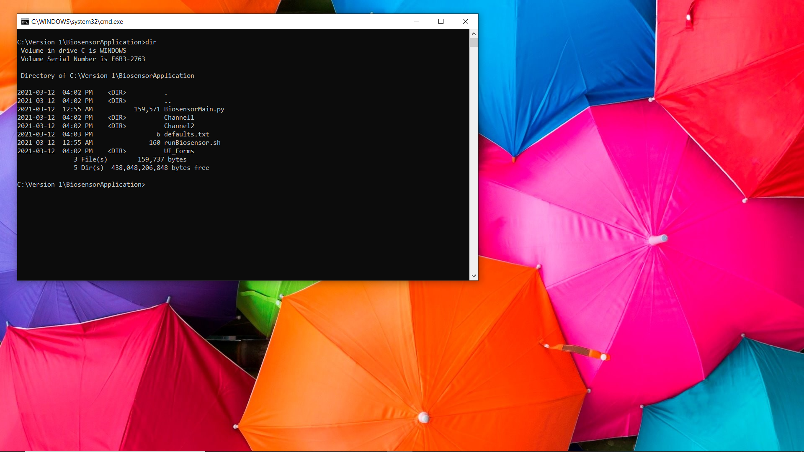

Run the command “*pyinstaller KORAD_PS_DAQ.py --onefile –windowed*”. This operation will take a few moments. The --onefile argument specifies to create a one-file bundled executable and the --windowed argument specifies that the program will not have a console window. **For testing purposes, do not use --windowed so the errors are visible in the console window.**

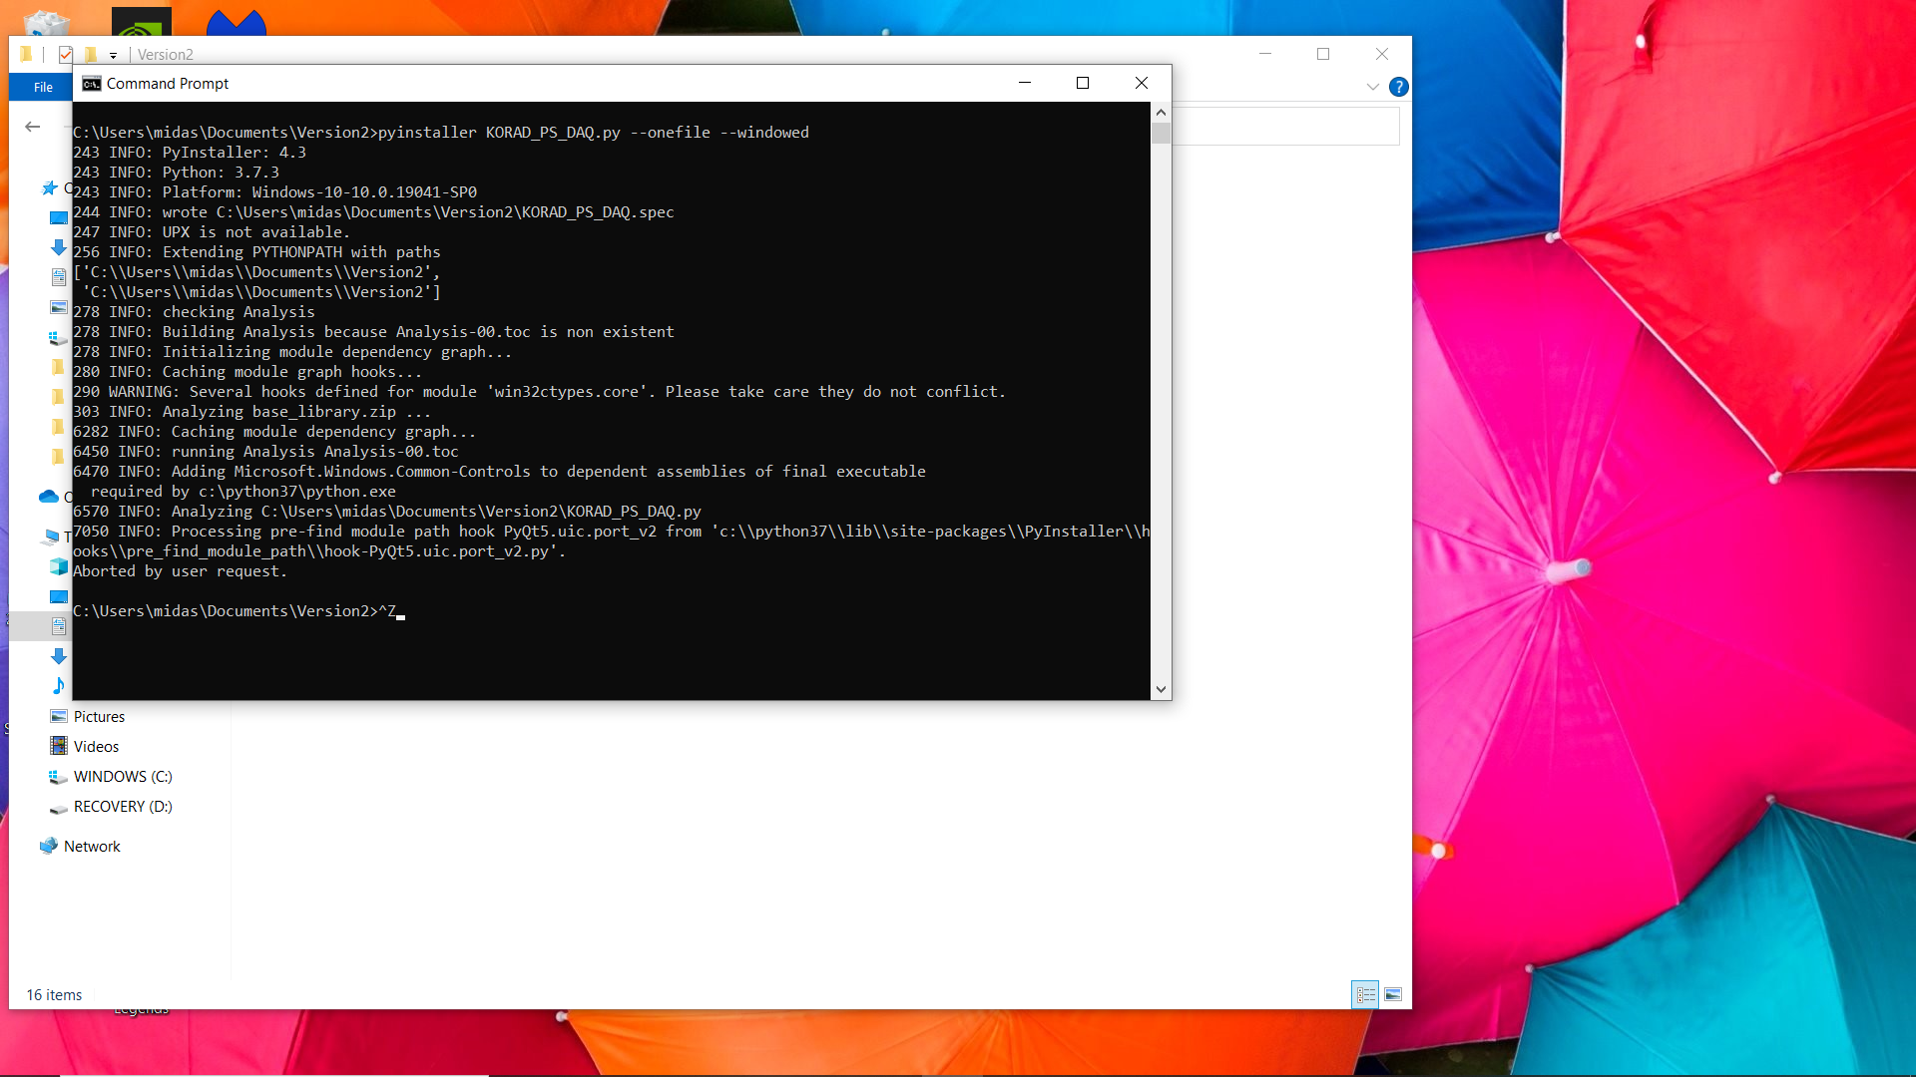

If you look inside the dist folder and the executable should be visible. Before debugging the executable, make sure both the .py file and the newly created .spec file is visible.

Now UI resources must be added exe. There are two methods to accomplish this, via command line or by editing the spec file. To edit via command line, you enter “*pyinstaller -F --add-data "path/to/ KORAD_PS_DAQ;/ KORAD_PS_DAQ " KORAD_PS_DAQ.spec”*, where *path/to/* is your literal path. The other method involves directly editing the .spec file. To add the data folder, I edited the .spec file using notepad. In the datas = [], add *("path\\to\\ KORAD_PS_DAQ ", "\\ KORAD_PS_DAQ ")* between the square brackets as shown below. **Read the following document if there are issues:** [**https://pyinstaller.readthedocs.io/en/stable/spec-files.html**](https://pyinstaller.readthedocs.io/en/stable/spec-files.html)

Then, in the terminal run *pyinstaller KORAD_PS_DAQ.spec* to re-compile the executable.

Now begins the debugging process for the exe. PyInstaller tends to fail to import certain modules when it packages everything. To find the missing modules the user can either navigate to the build directory and look through “warn- *KORAD_PS_DAQ*.txt” to find what is missing, or the user could look at the terminal output when the command *pyinstaller KORAD_PS_DAQ.py* was run and look for the keyword hidden import not found. Once found, they must be added to the hiddenimports. There are two methods to accomplish this, via command line or by editing the spec file. For more information, please look at the documentation above, but it is in a similar format as adding data. This is what my spec file looked like at the end.

Lastly, make sure to add the program icon to the executable. The path to your ico file will be different depending on where you are installing. Run *pyinstaller BiosensorMain.spec* again after saving the .spec file. This was my final .spec file.

**Note: As a final check, look at the executable in the dist folder. Check if the icon of the program has been updated. If not, copy the entire folder, and paste it into another location. See if the icon of your executable has been updated. If so, that means that icon has been set-up appropriately. Please remember the location of the dist folder. After, make sure to test the executable at least once to create the folders as shown below.**

1. Now, the executable needs to be packaged into the installation files. Depending on the user’s familiarity with windows installers (.msi) files this may be very straightforward. If the .msi route was chosen, Advanced Installer or MSI Wrapper could be used. In the documentation, Inno Setup was used due to its simplicity. Whichever option is chosen, make sure you have that product installed. Since Inno Setup was used, this documentation will be referring to that. The following websites were used as a reference point: <https://jrsoftware.org/isinfo.php> and <https://www.youtube.com/watch?v=Y9Ovo2XJHDs>.

After reading the documentation, the user can develop the script using the provided Inno setup script, *BiosensorInstallationScript.iss* located in *OnlineBiosensorMCU/Version 1/Installation files/Other files/*.

**NOTE:** **Before I started working on the script, I cleaned up the folder that contained my exe. Make sure only the exe and data folders are visible.**

**­**